# A guide on how to make and join participant teams.

**Participant Teams** enable individuals to collaborate and compete in AI challenges collectively. Forming a Participant Team allows members to combine their expertise, fostering innovative solutions and enhancing the competitive experience.​

## Creating a Participant Team:

1. **Sign Up or Log In:** Access the OpenPecha platform by registering a new account or logging into an existing one.​
2. **Select a Challenge:** Navigate to the 'Challenges' section and choose an active competition to participate in.​

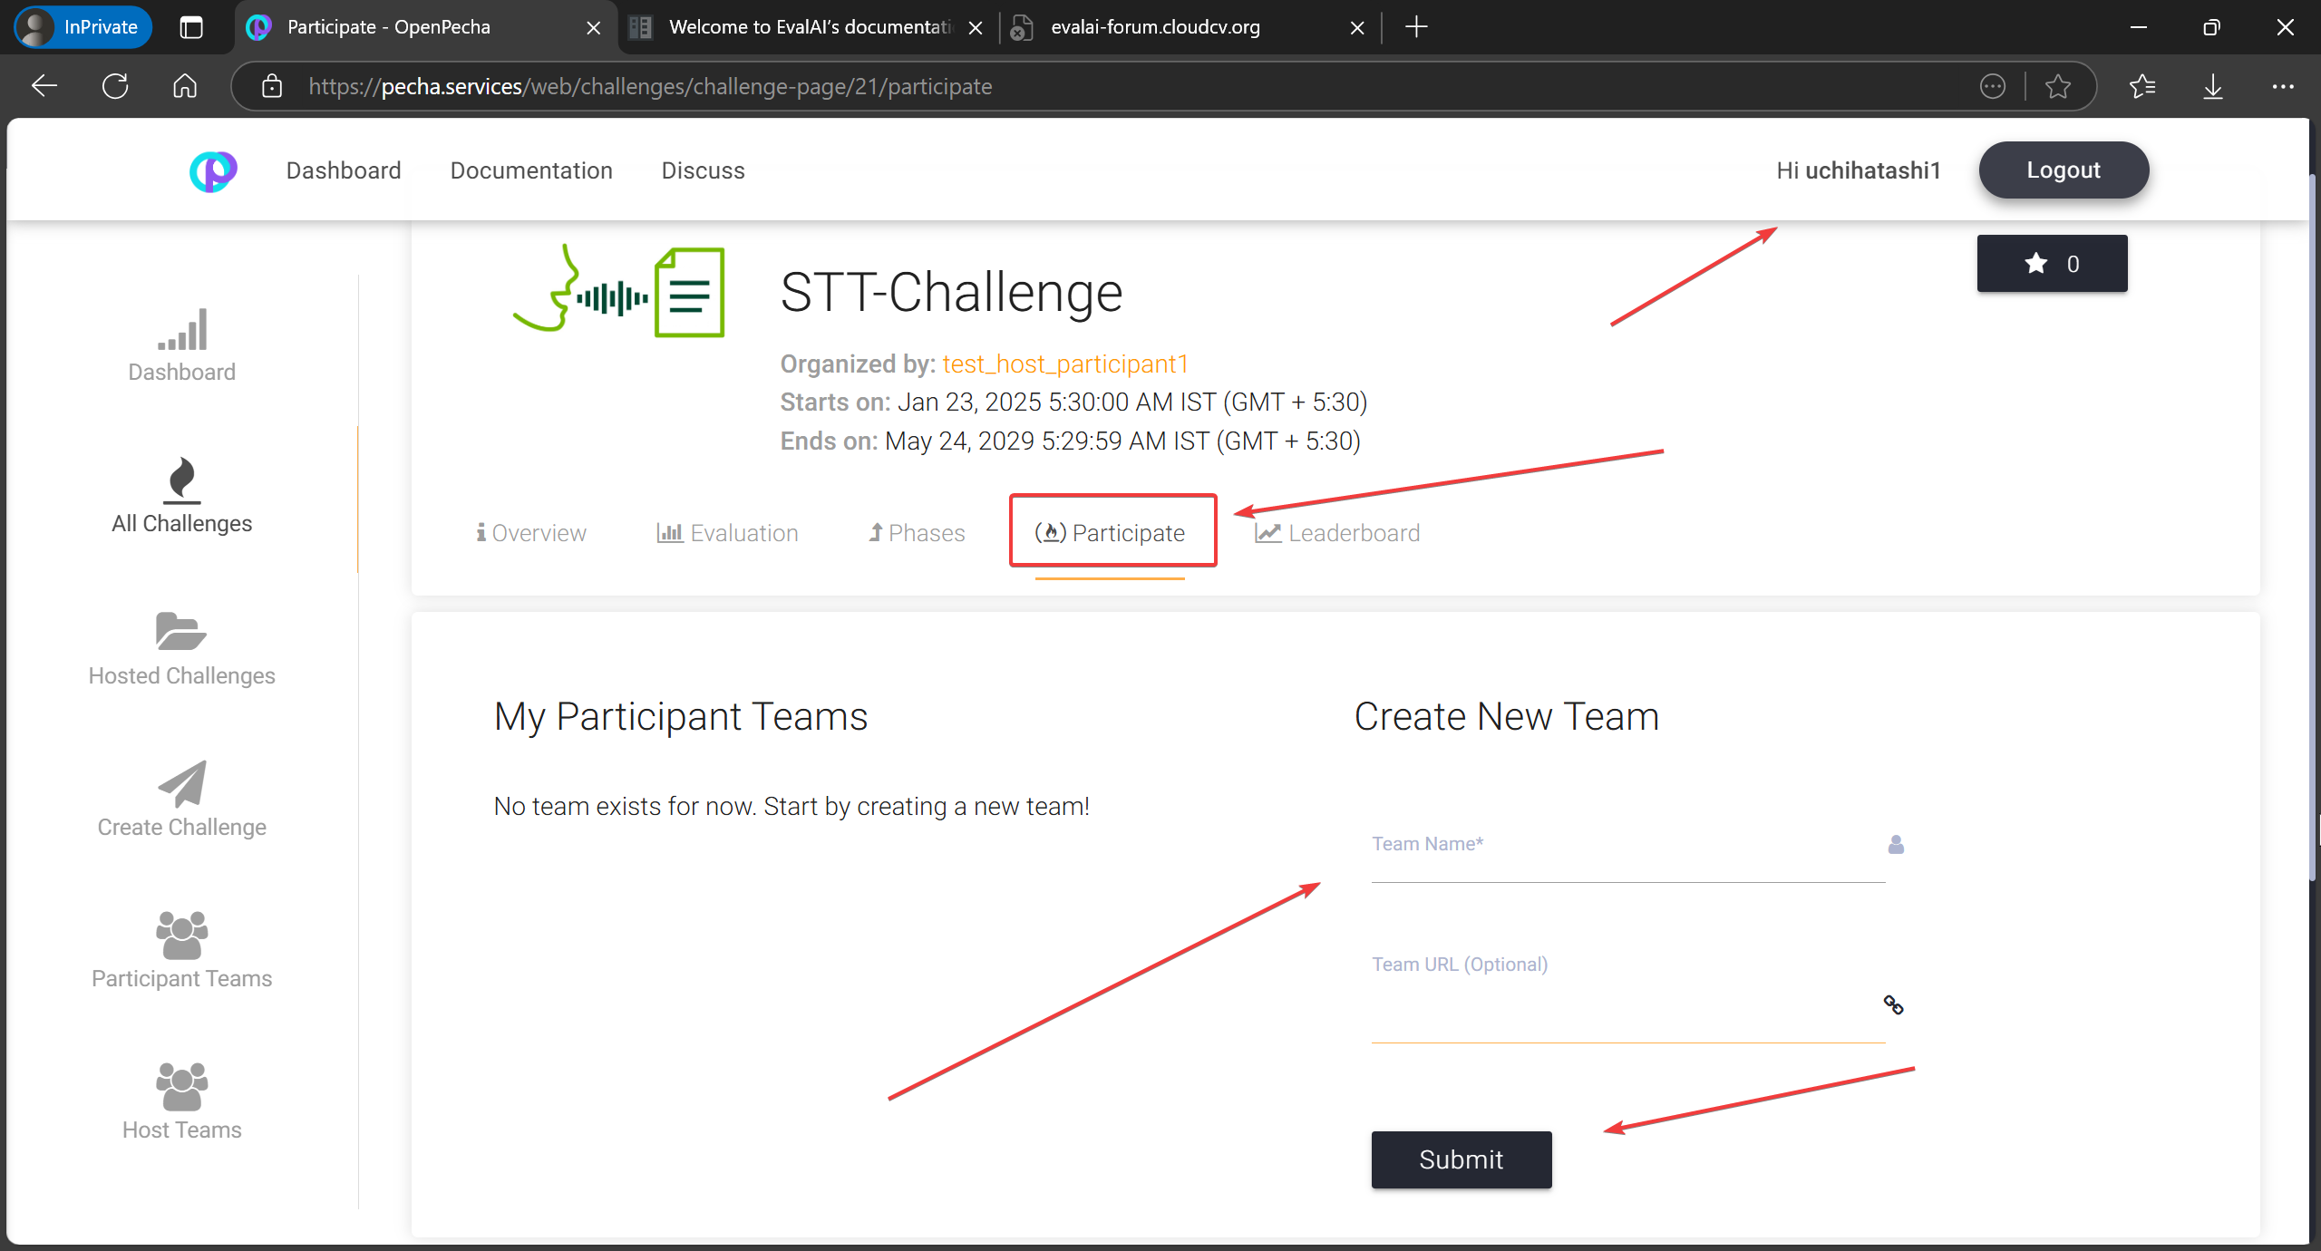

1. **Initiate Team Creation:** On the challenge page, click on the 'Create Participant Team' option.​

1. **Enter Team Details:** Provide a unique team name and an optional description to define your team's identity.​
2. **Finalize Team Setup:** Submit the form to establish your Participant Team, which will now be eligible to make submissions for the selected challenge.

## If you want to **reregister**, click here:

## ​Add Team Members in Participant team:

Click the "+" icon to invite members. Enter the email address associated with their OpenPecha account. Note that the system does not send notifications for these invitations; members are added directly without an acceptance step.

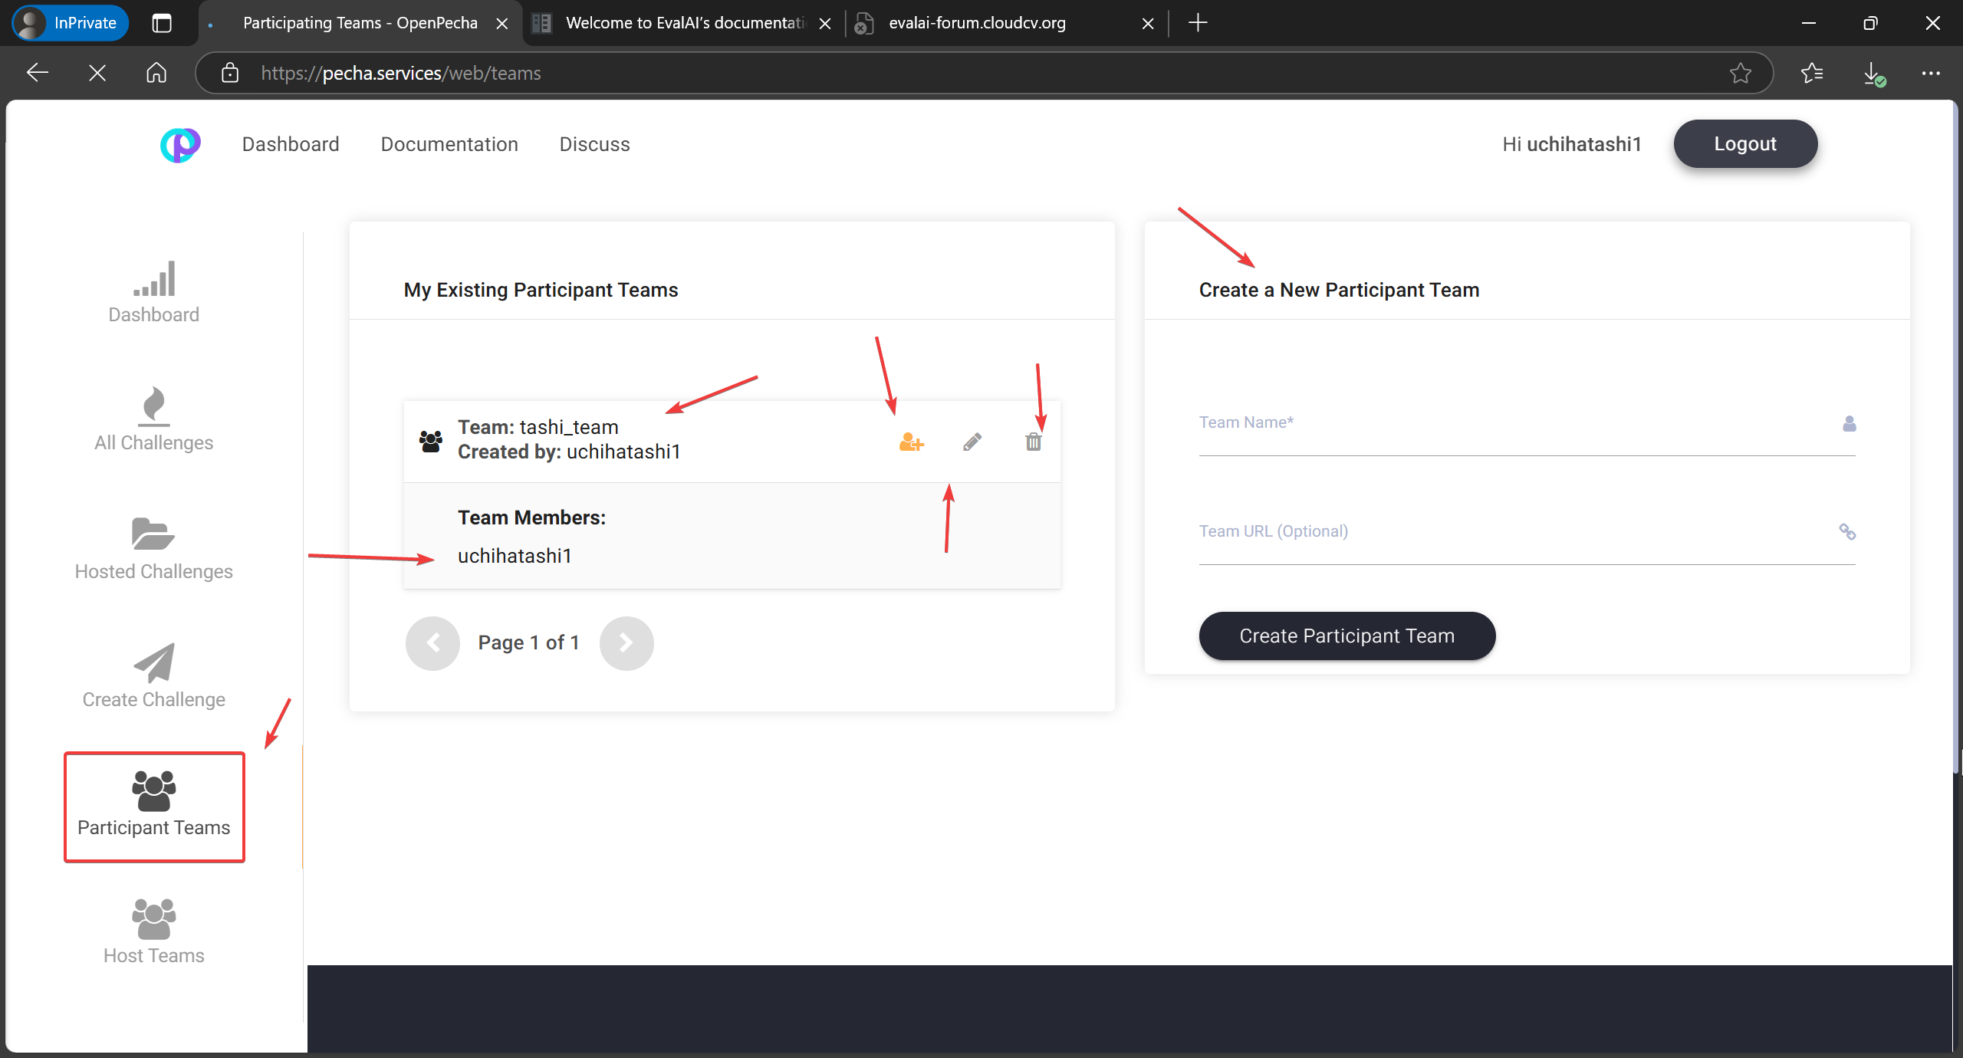

### The platform currently has limitations regarding team member management:​

* **Inability to Remove Team Members:** Once a member is added to a Participant Team, they cannot be removed through the user interface. If a participant adds a member by mistake, they must create a new team from scratch to rectify this. ​[GitHub](https://github.com/Cloud-CV/EvalAI/issues/2648?utm_source=chatgpt.com)
* **Equal Access Rights:** All team members have the same access rights within the team, which can pose challenges in managing team dynamics effectively.​

These issues have been acknowledged by the EvalAI development team, and discussions are ongoing to address them. For the latest updates and potential workarounds, users are encouraged to refer to the [EvalAI GitHub repository](https://github.com/Cloud-CV/EvalAI/issues/2648) and official documentation